Questions
Q1. The use of a pesticide may result in an increase in the number of pest organisms that
are resistant to the pesticide.
Use your knowledge of natural selection to explain the increase in the number of
pest organisms that are resistant to the pesticide.
(5)
..............................................................................................................................................
..............................................................................................................................................
..............................................................................................................................................
..............................................................................................................................................
..............................................................................................................................................
..............................................................................................................................................
..............................................................................................................................................
..............................................................................................................................................
..............................................................................................................................................
..............................................................................................................................................
..............................................................................................................................................
..............................................................................................................................................
..............................................................................................................................................
..............................................................................................................................................
..............................................................................................................................................
..............................................................................................................................................
(Total for question = 5 marks)

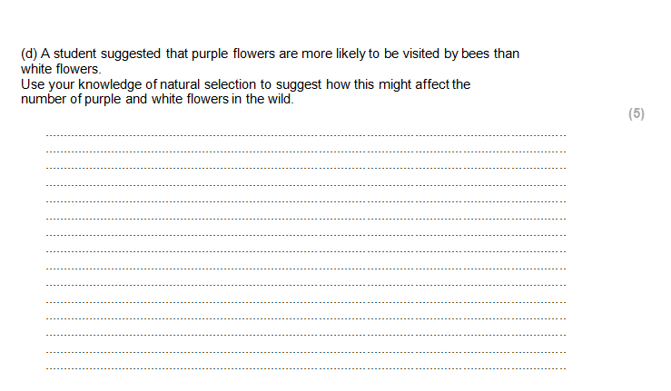
Questions
Q1.
The use of a pesticide may result in an increase in the number of pest organisms that
are resistant to the pesticide.
Use your knowledge of natural selection to explain the increase in the number of
pest organisms that are resistant to the pesticide.
(5)
..............................................................................................................................................
..............................................................................................................................................
..............................................................................................................................................
..............................................................................................................................................
..............................................................................................................................................
..............................................................................................................................................
..............................................................................................................................................
..............................................................................................................................................
..............................................................................................................................................
..............................................................................................................................................
..............................................................................................................................................
..............................................................................................................................................
..............................................................................................................................................
..............................................................................................................................................
..............................................................................................................................................
..............................................................................................................................................
..............................................................................................................................................
..............................................................................................................................................
..............................................................................................................................................
..............................................................................................................................................
..............................................................................................................................................

(Total for question = 5 marks)

Questions
Q1.
The use of a pesticide may result in an increase in the number of pest organisms that
are resistant to the pesticide.
Use your knowledge of natural selection to explain the increase in the number of
pest organisms that are resistant to the pesticide.
(5)
..............................................................................................................................................
..............................................................................................................................................
..............................................................................................................................................
..............................................................................................................................................
..............................................................................................................................................
..............................................................................................................................................
..............................................................................................................................................
..............................................................................................................................................
..............................................................................................................................................
..............................................................................................................................................
..............................................................................................................................................
..............................................................................................................................................
..............................................................................................................................................
..............................................................................................................................................
..............................................................................................................................................
..............................................................................................................................................
..............................................................................................................................................
..............................................................................................................................................
..............................................................................................................................................
..............................................................................................................................................
..............................................................................................................................................

(Total for question = 5 marks)

Mark Scheme
Q1.

