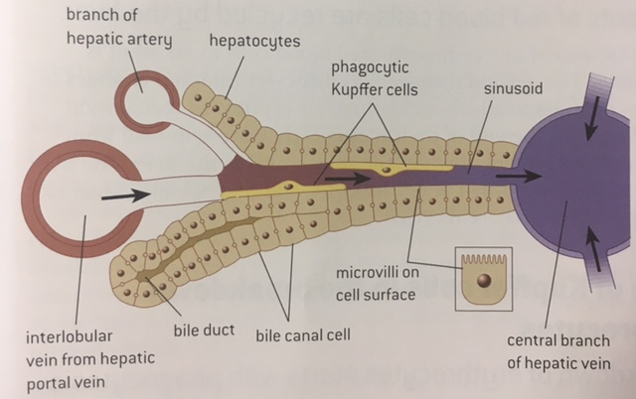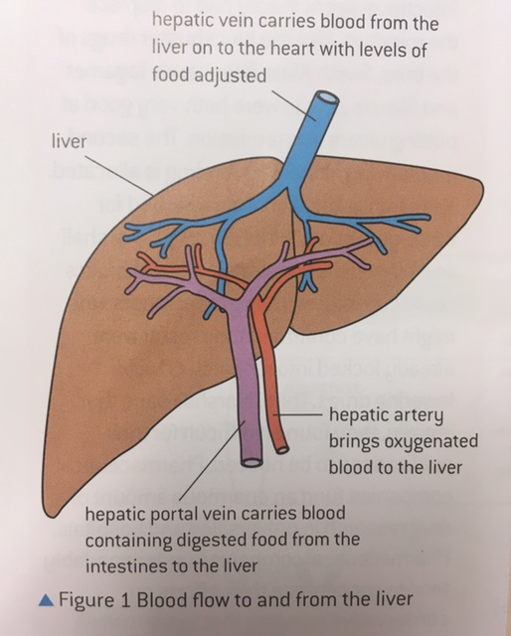

**Detoxification:**

**Production of plasma proteins by hepatocytes (liver cells):**

**Conversion of cholesterol to bile salts:**

**Transport of iron to the bone marrow to form new haemoglobin**:

**Breakdown of red blood cells (erythrocyrtes) by Kupffer Cells:**

**Storage of nutrients**

Glucose as glycogen:

**Processing of nutrients**

Glucose:

Proteins and amino acids:

Lipids: