1. (a) Draw and label a simplified structure of a nucleotide.
(2)

A genetic cross was made between pure-breeding snapdragon plants with red flowers and pure-breeding snapdragon plants with white flowers. The cross produced F1 offspring that had only pink flowers. When the F1 plants were self-pollinated, the resulting F2 generation had some red, some white and some pink flowers.
(b) (i) Identify the relationship between the red and white alleles for flower colour.
..........................................................................................................................
(1)
(ii) Deduce the genotype of the F1 plants.
..........................................................................................................................
(1)
(iii) Construct a Punnett grid to show the cross between two F1 plants.

(2)
(iv) Deduce the proportion of the different phenotypes of the F2 offspring.
..........................................................................................................................
..........................................................................................................................
(1)

(Total 7 marks)

2. (a) Define the term co-dominance.
.....................................................................................................................................
.....................................................................................................................................
(1)

(b) A man of blood type AB and a woman of blood type B are expecting a baby. The woman’s mother had blood type O. Deduce the possible phenotypes of the offspring from the cross shown below.
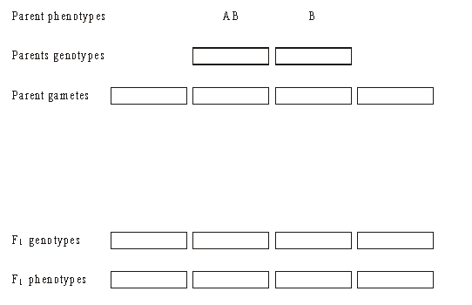
(4)
(Total 5 marks)

