- The pedigree chart below shows the blood types of three members of a family.
Which could be the blood types of individuals 1 and 2?

 | Individual 1 | Individual 2
A. | A | AB
B. | AB | B
C. | O | B
D. | B | A
(Total 1 mark)
2. A man of blood group A and a woman of blood group B have a child. If both are heterozygous for the gene, what are the chances of them having a child with blood group B?
A. 0%
B. 25%
C. 50%
D. 75%
(Total 1 mark)
3. Which of the following genotypes is possible in the offspring of a homozygous male with blood group A and a female with blood group B?
A. IAIA
B. IAi
C. ii
D. IBi
(Total 1 mark)
4. A woman who is a carrier for hemophilia and a man who does not have hemophilia have a child.
What is the probability that the child will have hemophilia?

 | If it is a girl | If it is a boy
A. | 0% | 50%
B. | 0% | 0%
C. | 50% | 50%
D. | 50% | 0%
(Total 1 mark)
5. What is a suspected heterozygous individual crossed with in a test cross?
A. Homozygous dominant
B. Homozygous recessive
C. Heterozygous dominant
D. Heterozygous recessive
(Total 1 mark)
6. A parent organism of unknown genotype is mated in a test cross. Half of the offspring have the same phenotype as the parent. What can be concluded from this result?
A. The parent of unknown genotype is heterozygous.
B. The parent of unknown genotype is homozygous dominant.
C. The parent of unknown genotype is homozygous recessive.
D. The parent of known genotype is heterozygous.
(Total 1 mark)
7.
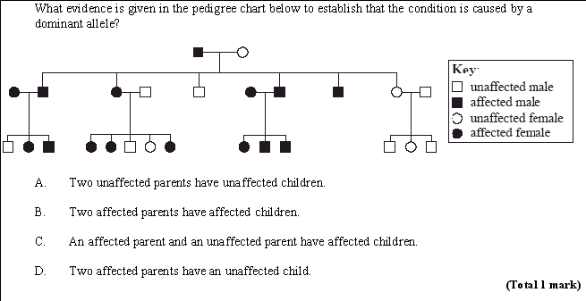

8. Boys can inherit the recessive allele (c) that causes red-green colour blindness from their mother, not from their father. The allele for normal red and green vision is C. Which of the following genotypes are possible in men?
A. c only
B. C or c only
C. CC or cc only
D. CC, Cc or cc only
(Total 1 mark)

