1. The drawing below shows the structure of a virus.
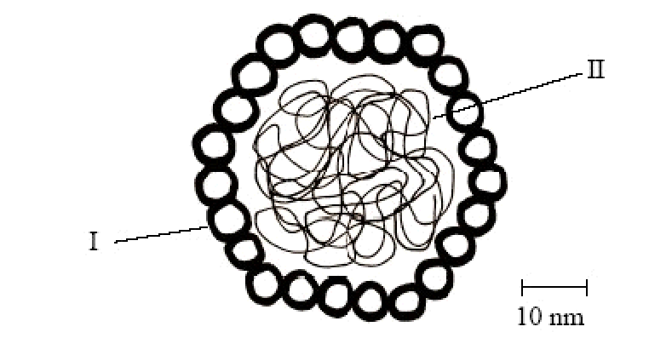

(a) Identify structures labelled I and II.
I: ...........................................................................................................................
II: ...........................................................................................................................
(2)
(b) Use the scale bar to calculate the maximum diameter of the virus. Show your working.

Answer: .....................................................
(2)
(c) Explain briefly why antibiotics are effective against bacteria but not viruses.
.....................................................................................................................................
.....................................................................................................................................
.....................................................................................................................................
.....................................................................................................................................
.....................................................................................................................................
.....................................................................................................................................
.....................................................................................................................................
(3)

(d) Explain how antibiotic resistance develops in bacteria.
.....................................................................................................................................
.....................................................................................................................................
.....................................................................................................................................
.....................................................................................................................................
.....................................................................................................................................
.....................................................................................................................................
(3)
(Total 10 marks)

1. What does the nucleus of a human lymphocyte contain?
A. Only the genes to produce a specific antigen
B. Only the genes to produce a range of antibodies
C. Only the genes that control the growth and development of a lymphocyte
D. The whole genetic information for a human
(Total 1 mark)
2. Which term describes a molecule capable of triggering an immune response?
A. Antibody
B. Antigen
C. Pathogen
D. Antibiotic
(Total 1 mark)

3. What stimulates the production of antibodies?
A. AIDS
B. Antibiotics
C. Anticodons
D. Antigens
(Total 1 mark)

4. The diagrams show the death rate in January from influenza in Canada and the United Kingdom (UK). Canada is a very large, sparsely populated country. The United Kingdom is a densely populated island.
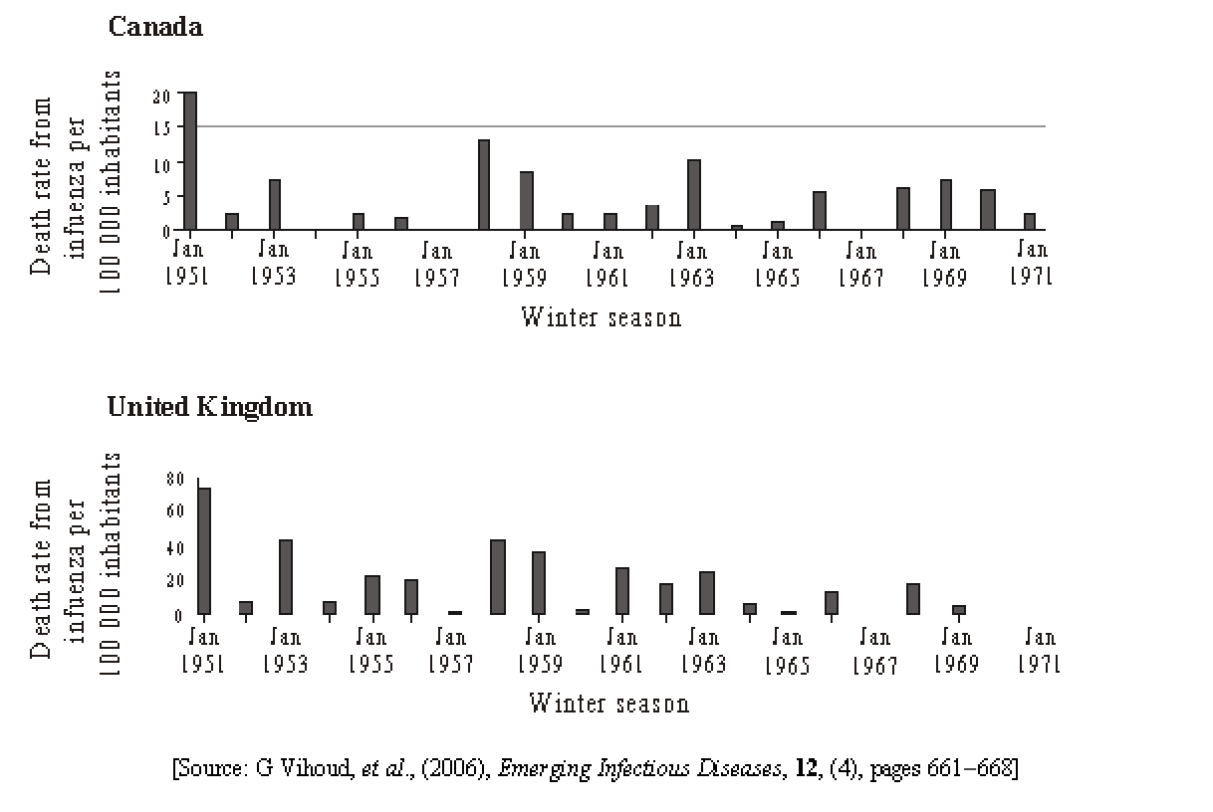

(a) (i) Identify the year in which there were no observed deaths from influenza in either country.
...........................................................................................................................
(1)

(ii) Calculate the total number of deaths from influenza in 1968 in Canada assuming the population size was 19.8 million.
...........................................................................................................................
(1)

(b) Compare the death rates between Canada and the United Kingdom between 1953 and 1963.
.....................................................................................................................................
.....................................................................................................................................
.....................................................................................................................................
(3)

(c) Influenza is caused by a virus. Outline the diversity of structure in viruses.
.....................................................................................................................................
.....................................................................................................................................
.....................................................................................................................................
.....................................................................................................................................
(2)
(Total 7 marks)

1. (a) I: protein coat / capsid / capsomere; II: DNA / nucleic acid / RNA / genetic material; 2

(b)
52 nm (±5 nm); (units required) 2

(c) antibiotics block specific metabolic pathways / cell production in bacteria; viruses reproduce using the host cell metabolic pathways; (host cell) pathways are not affected by antibiotics; viruses do not have metabolic pathways; 3 max

(d) some bacteria are resistant to an antibiotic / variation within bacterial populations includes antibiotic resistance; genes for antibiotic resistance originate as mutations (not caused by antibiotics); transfer of resistance genes (can occur) from strain to strain / species to species; bacteria that are resistant survive when an antibiotic is used and others die; resistant bacteria pass on their genes for resistance to offspring; proportion of resistant bacteria increases in each generation in the population / species; natural selection for bacteria that are resistant; 3 max
[10]

1. D
[1]
2. B
[1]
3. D
[1]
4. (a) (i) 1967 1
(ii) (death rate = 5 per 100,000 / yr, total number of deaths would be 5 times 198 =) 990 deaths 1

(b) death rate in Canada is always lower than United Kingdom;
highest death rate in United Kingdom approx 40 per 100,000 whereas in Canada never above 15;
no death from influenza recorded in Canada in 1957 but some in the
United Kingdom;
highest death rate for United Kingdom recorded in 1953 but in Canada in 1958;
both countries have very low / zero death in 1954 and 1957;
between 1953 and 1963 patterns are very similar; 3 max

(c) viruses consist of nucleic acid and a protein coat;
DNA double stranded or single stranded;
RNA double stranded or single stranded;
protein coat contains receptors specific for target organism; 2 max
[7]

