Immobilised enzymes

Equipment:

- Sodium alginate
- Calcium chloride dehydrate
- Yeast
- Distilled water
- 2 % Hydrogen peroxide
- 3 x 250ml beaker
- 1 x conical flask
- 1 x gas syringe
- 1 x plastic syringe
- 1 x sieve
- clamp stand
- 2 x Stirring spoon

Method:

- In a beaker mix 4g sodium alginate with 100ml distilled water. Keep stirring.
- In a different beaker mix 4g calcium chloride dehydrate with 200ml distilled water.
- In a different beaker mix 10g yeast with 100ml distilled water.

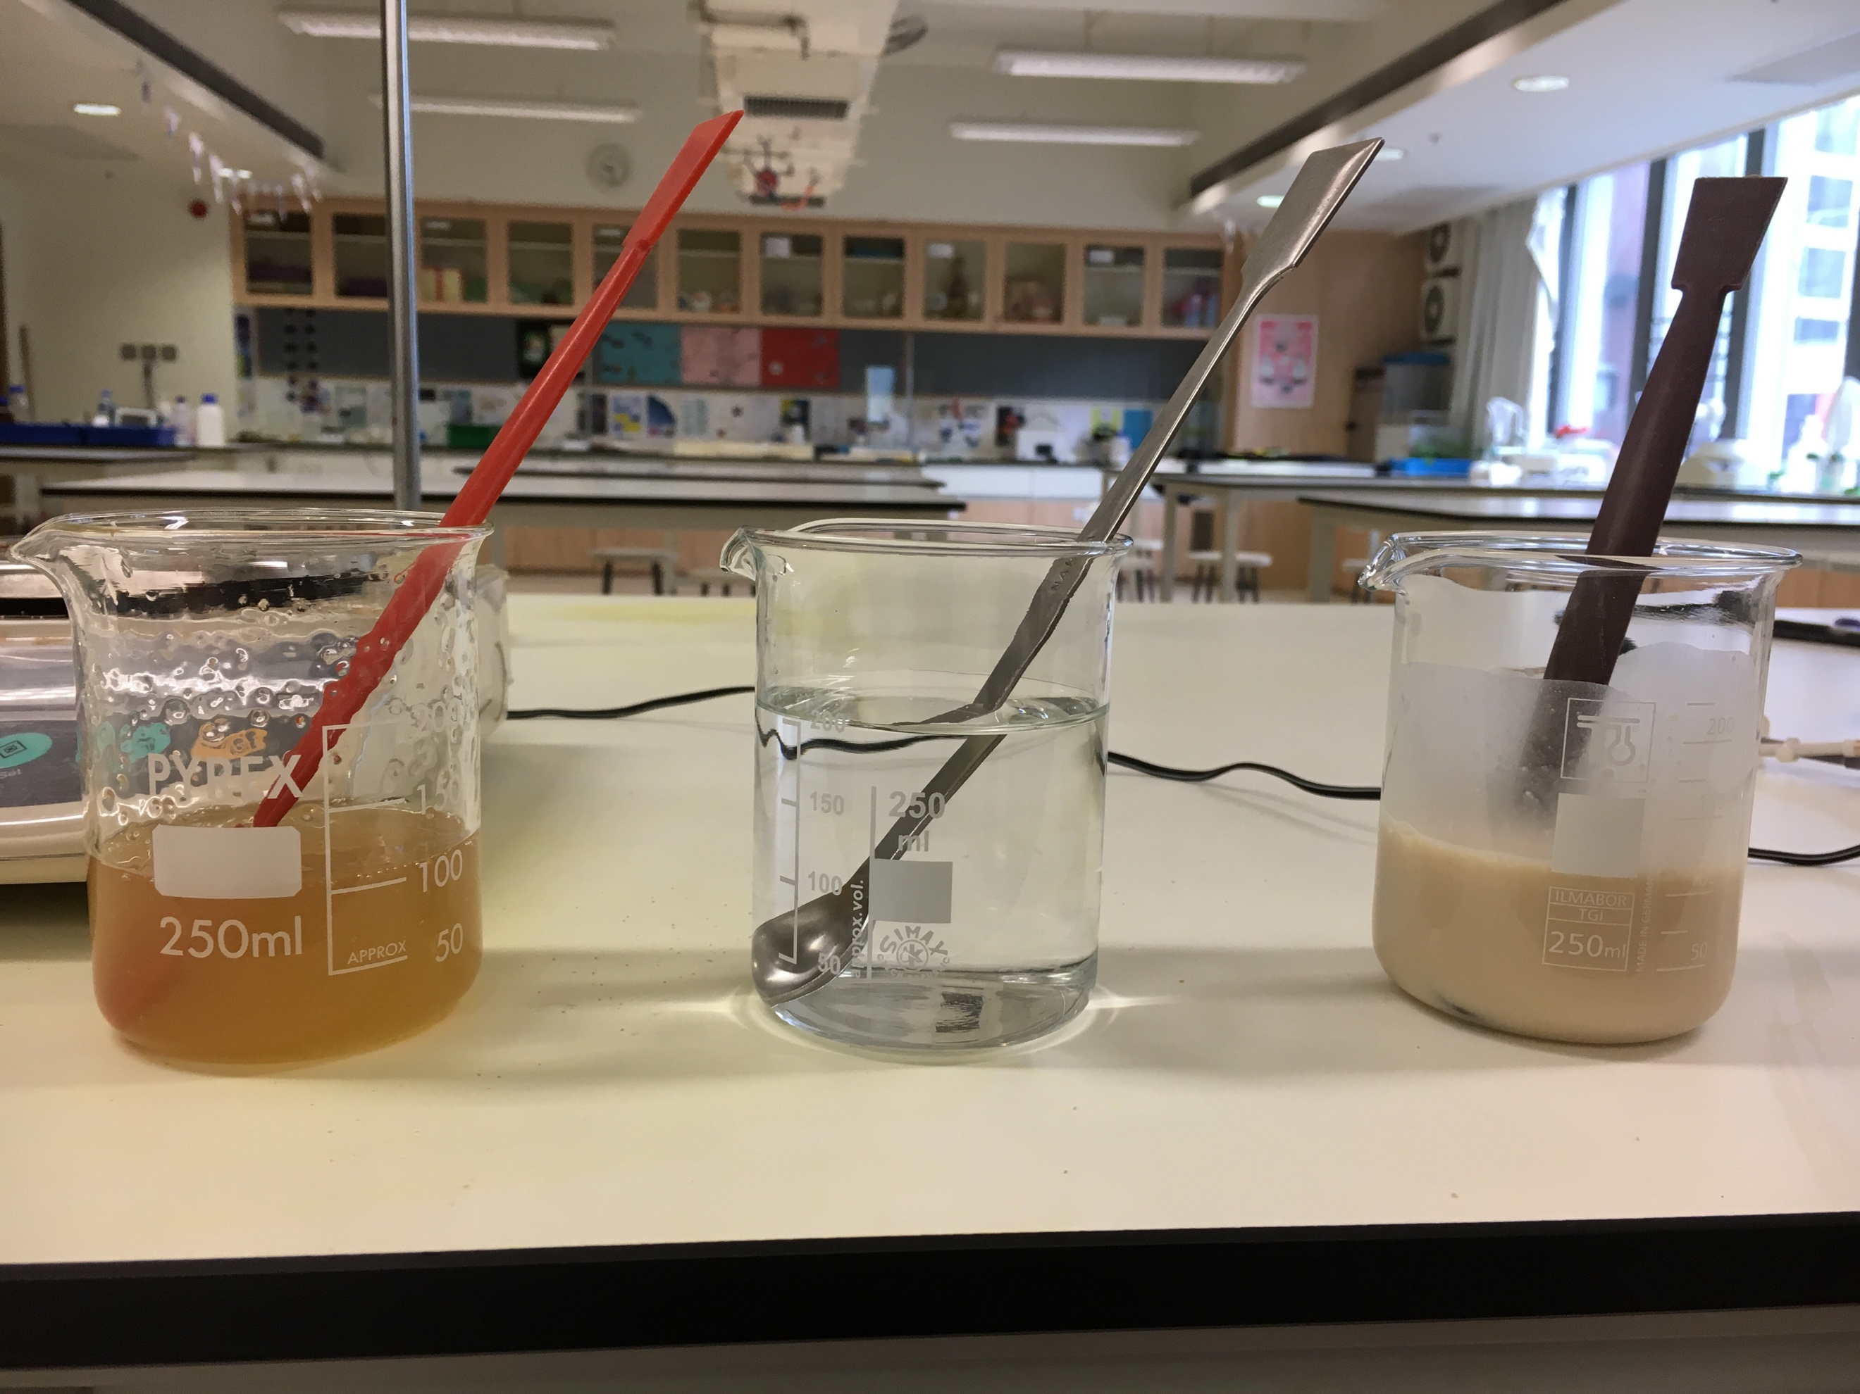
- Once the sodium alginate is fully dissolved add it to the yeast solution. Stir.
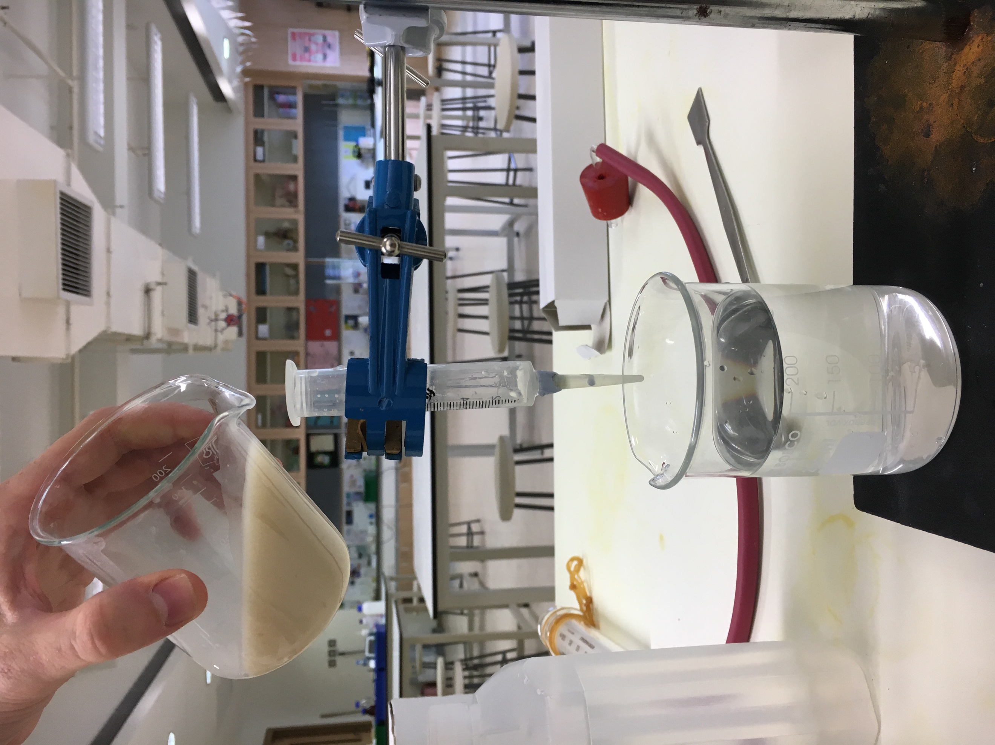
- Set up the clamp and plastic syringe as shown this the picture. Add the tip of a dropper to the syringe (ask).
- Set up so the tip of the plastic syringe is 5cm away from the surface of the calcium chloride dehydrate.
- Add the yeast/sodium alginate mixture VERY SLOWLY to the top of the plastic syringe.
- Observe. You should be making small enzyme balls in the calcium chloride dehydrate. These are immobilized enzymes.
- Wash out your sodium alginate beaker (that is now empty).
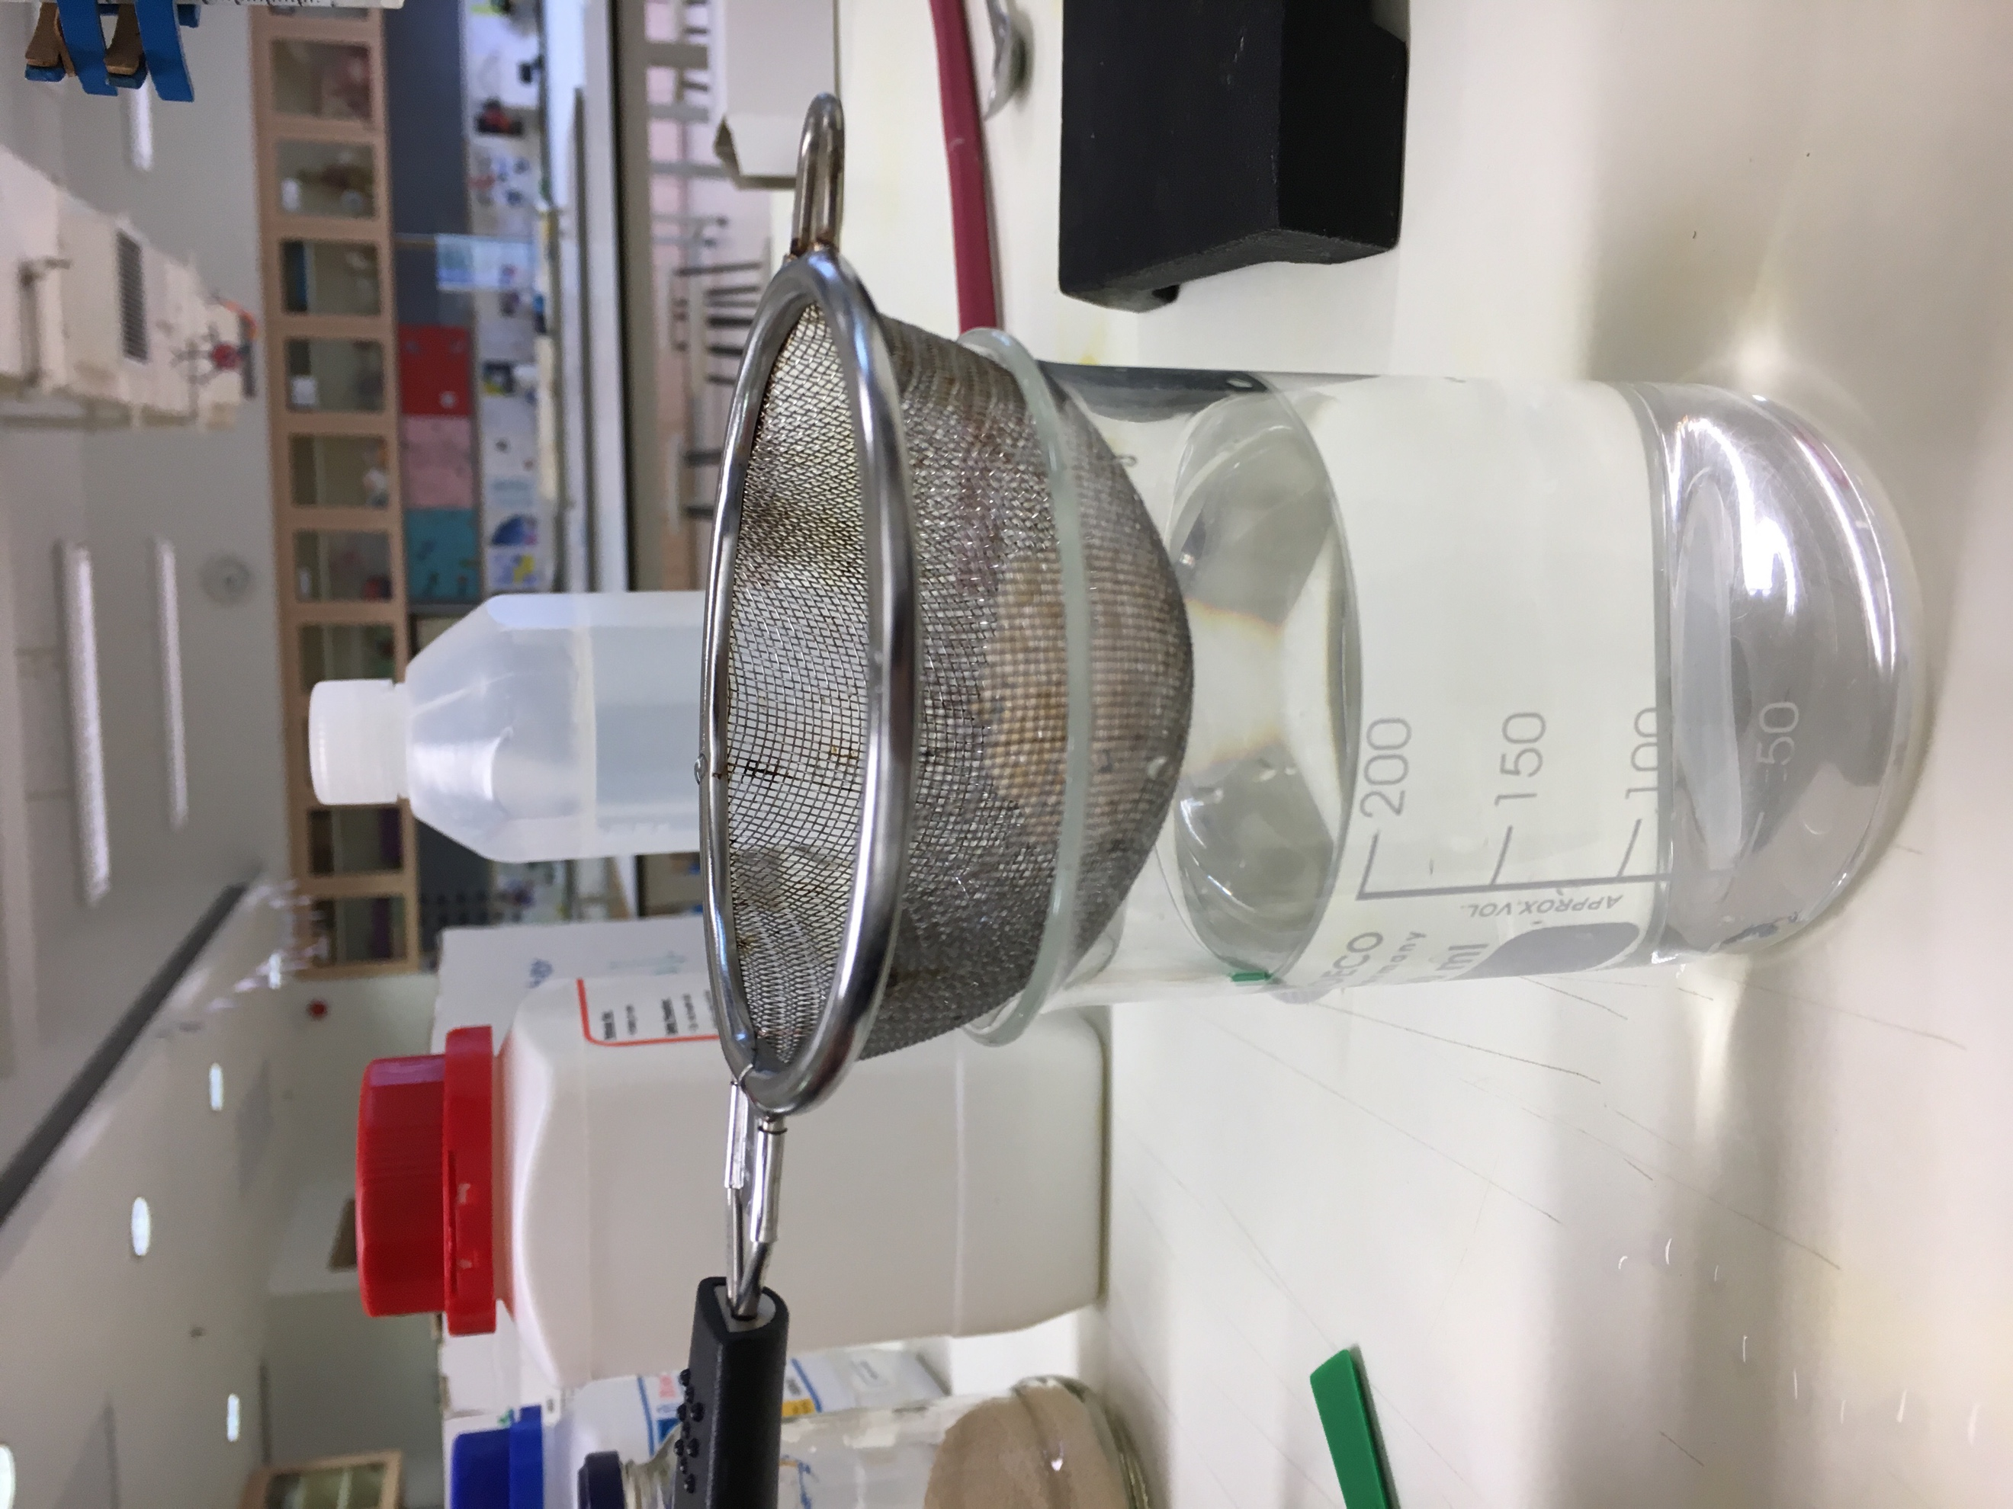
- Use a sieve to separate the immobilized enzyme balls from the calcium chloride dehydrate.

- Rinse immobilized enzymes with distilled water. Remover any that don’t look like balls.
- Add 10g immobilized enzyme balls to a conical flask.
- Set up a clamp stand with a gas syringe and delivery tube.
- Add 50ml hydrogen peroxide to the immobilized enzyme balls. Bung in. Measure the volume of oxygen produced in 30 seconds.
- Seive balls. Rinse balls. Repeat.

Are the results repeatable? Can you use the immobilized enzymes multiple times and get the same results? Record your results in the space below.

