Heating Curves

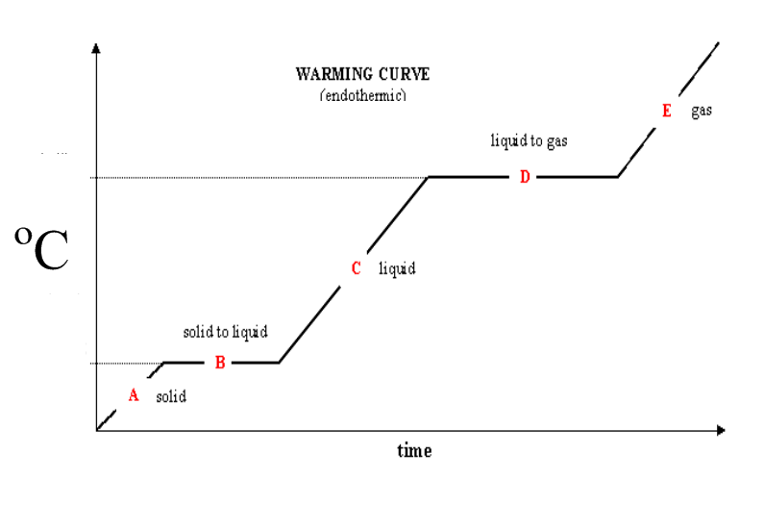

The graph above shows the temperature of water as it is heated

- Describe the shape of the graph

- What is happening at point B?

- What is happening at point D?

- Why do you not have a reading for point E from your investigation?

- Draw particle diagrams to show the arrangement of particles at point A, C, E. Identify the state the water in in.

A | C | E
State = | State = | State =

States of matter

You need to find the answers to the following questions

- What are the only two elements on the periodic table that are liquid at room temperature?

- State one non-metal element from the periodic table that is a solid at room temperature.

- State one element from the periodic table that is a gas at room temperature.

- List the properties of solids, liquids and gases:

Solids | Liquids | Gases

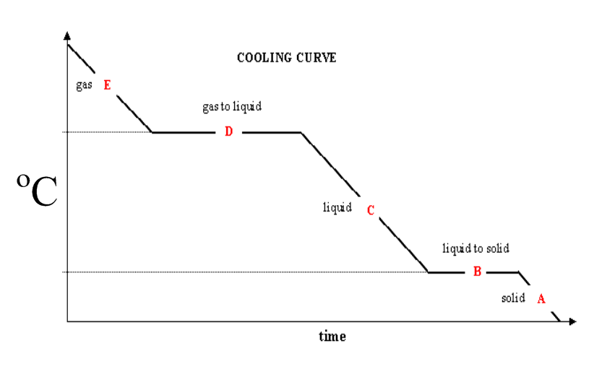
What is happening at:

D =

B =

If this is a cooling curve for water, what temperature do you expect D and B to happen?

D =

B =

