The Peppered Moth
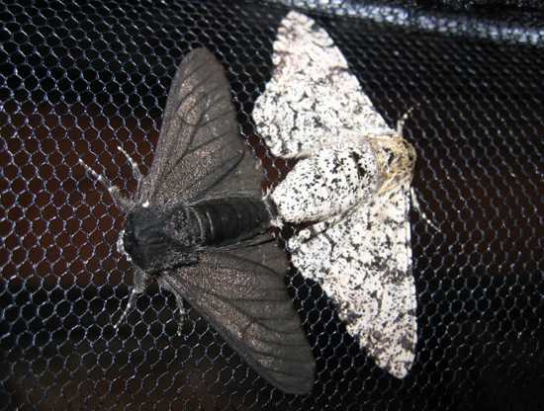
Originally, the vast majority of peppered moths (Biston betularia) had a light, mottled coloring which was a good camouflage against predators. This is because they could usually be found on the bark of trees which has a similar colouring. Before the industrial revolution, a dark variant of the peppered moth made up 2% of the species.
After the industrial revolution, 95% of peppered moths showed this dark coloration. The best explanation as to why this change in the species occurred is that the light moths lost their advantage of camouflage as light surfaces of trees were darkened by pollution, and so light moths were eaten more frequently by birds.
This shows a major shift in a species caused by mutations leading to variation and natural selection.

The Arms Race between Crabs and Mussels
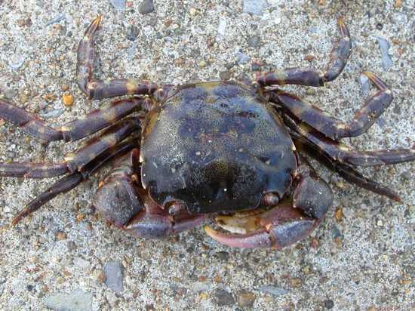
Evolution often happens in tandem; a predator evolves an improved hunting method, and any mutations in the prey species that aid survivability will be selected for leading to a change in the prey population. ‘An arms race!’
The Asian shore crab (Hemigrapsus sanguineus) is an invasive species in New England (USA), which feeds on the native blue mussels. It has recently been observed that mussels, when they detect Asian shore crabs, develop thicker shells, by producing a structural protein, to stop the crabs eating them.
The evolutionary factor here is that only mussels from regions where Asian shore crabs are living will have thick walls. The crabs that live in areas with high populations of the thick walled mussels are developing stronger muscles in their claws.

Italian Wall Lizards
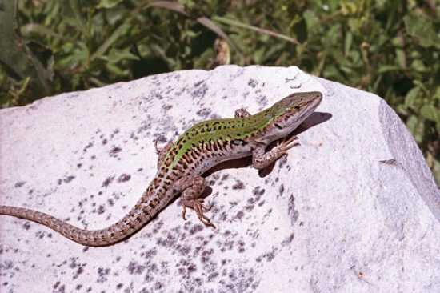
In 1971, ten Italian wall lizards (Podarcis sicula) were introduced to the island of Pod Mrčaru from a neighboring island. The lizards were left for decades, and compared to the colony from which they were taken (Italian wall lizards were compared from the two islands).
The wall lizards on Pod Mrčaru, were found to have thrived and adapted to their new island. They were found to have shifted from a mainly insectivorous (eating insects) diet to one heavy in vegetation (the original island had very little plant life and the new island had lots of plant life). This diet change seems to have driven dramatic changes in the lizards. The head of the Pod Mrčaru lizards is larger, and has a far greater bite force. These are key adaptations for dealing with chewing leaves. The most exciting sign of evolution is the development of cecal valves, muscles used to separate portions of the intestine. These serve to slow the passage of food through the intestine and give time for the bacteria in the gut to breakdown the plant matter for absorption. These valves are more apparent in the lizards from the second island. A vegetarian diet needs to pass through the intestines slower in order to break down the plant matter.
This is an entirely novel development in the Italian wall lizard, and a major adaptation.

Cane Toads
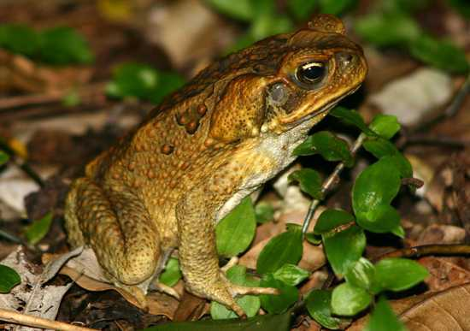
The cane toad in Australia is probably one of the world’s most famous invasive species. It does immense harm to agriculture and native species. Australia is big, for those who don’t know, and it takes time for an invasive species to spread.
Those toads at the front of the invasion wave are likely those best adapted for spreading fastest. Of course, these fast-spreading toads will breed with each other as only other fast toads will be at the front. This is charmingly called ‘the Olympic village effect’ and will reinforce the adaptations which put these toads at the front. When toads at the front of the invasion wave were studied, they were found to be bigger, hardier, had longer legs allowing for greater speed, and were more active. As a result of these sorts of adaptations the rate at which cane toads spread has been increasing ever since they were introduced.
The ones at the front of the race were clearly better adapted to travelling across Australia. The toads at the front of the race and the toads at the back have different characteristics. I am sure you can imagine what they are.

Darwin’s Finches
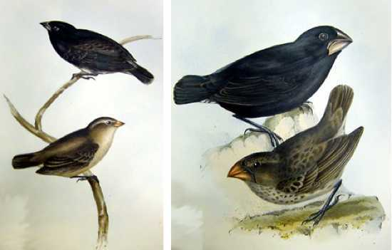
On the Galapagos Islands in the Pacific Ocean, close to the equator, there are a variety of different finches, which vary in the shape and size of their beaks. It appears that the finches colonised the Islands from mainland South America, and then diverged in form. The distance between the islands meant that the finches on different islands could not interbreed, so the populations on the different island tended to become distinct. Different populations also became specialised for different food sources, birds with thin, sharp beaks eating insects and birds with large, sturdy beaks eating nuts. Darwin noticed that the finches were very well adapted for the food sources on the individual islands.
Darwin collected some of these finches when he visited the Galapagos Islands, and it is often stated that the finches were key to the development of his theory of evolution. They are used as evidence for his theory in many textbooks.

Butterflies and Parasites
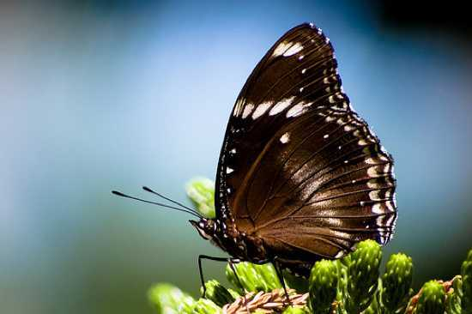
Studying evolution can take decades, but occasionally change happens incredibly rapidly. The Blue Moon Butterfly (Hypolimnas bolina) of the Samoan islands was being attacked by a parasite which destroyed male embryos. This led to a gender imbalance whereby males made up only 1% of the butterfly population. However, within ten generations (~1 year) males had returned to 40% of the population.
This is not because the parasite has disappeared, it is still present, but it is no longer deadly to male embryos. The male embryo can now resist infection by the parasite due to a mutation in a single butterfly. This butterfly reproduced and passed on its genes. This case shows how a mutation giving an advantage can rapidly spread throughout a population. Any male with the ability to survive infection would be able to mate with a great many females.

The species has evolved. It is important to realize that evolution doesn’t always mean drastic changes to physical appearance.

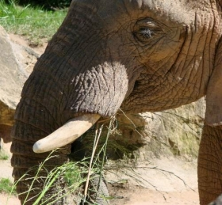

Elephants Evolve Smaller Tusks Due to Poaching
A species’ evolution has long been thought to take thousands of years to produce seemingly minor changes.
It appears that in at least one case, however, evolution is occurring at what seems like jet speed. In the last 150 years, the world’s elephant population has evolved much smaller tusks.
The average size of an African elephant’s tusks has gone down by half in the last century and a half. Indian elephants have undergone a similar tusk size reduction.
Experts believe the rapid evolution of the massive land mammals is due to poaching. Zoologists from Oxford University suggest that ivory poachers, who go for the largest males with the largest tusks, have caused the breeding behaviours of the animals to change rapidly in a short time
The largest male African elephants have the largest tusks. These tusks are extremely important in elephant behaviour, with the largest tusks usually resulting in more successful intimidation of smaller males or winning fights for female elephants. But when the largest animals are killed, it changes the breeding patterns of the animals. In short, without the largest males for competition, the smaller males with their smaller tusks will breed more successfully, and their offspring will have smaller tusks.
Study co-author Iain Douglas Hamilton of Save the Elephants said in the Telegraph: “What appears to be the case is that average tusk sizes have decreased greatly since the mid-19th century. The data comes from the trade statistics and from records of hunters around Africa who find that large trophies are very much harder to find. While some of this may be due to an absence of older animals, it is possible there has been a genetic selection pressure against large tusk size that outweighs their usefulness in contests with other males in winning females.”

Live Birth in Three-toed Skinks
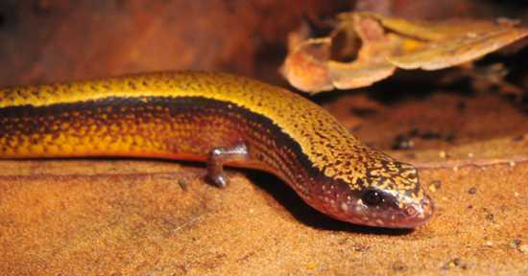

Speciation (development of distinct species through evolution) involves many mutations leading to significant changes. The yellow bellied three-toed skink (Saiphos equalis) is a lizard of New South Wales, in Australia, that appears to be undergoing the change from laying eggs to live birth. Since these skinks can either lay eggs or give birth, it gives scientists the chance to study the adaptations necessary for live birth. Skink embryos encased in an egg have an extra source of calcium that the live born skinks lack. It turns out that this nutritional difference is made up by the mother secreting extra calcium for the young held inside her.
This looks like the first step on the road to developing a system like the mammalian placenta. Skinks living on the coast tend to lay eggs, probably because the warm weather is predictable and sufficient for embryonic development. Those skinks living in the cooler mountains tend to give birth to live young, the mother’s body providing a more stable temperature. It is to be predicted that these two populations will at some point separate into different species as each population becomes fixed in its reproductive strategy.

