1. The diagram shows a longitudinal section through part of the axon of a myelinated neurone.

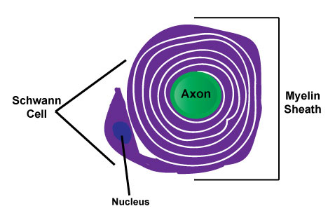
(a) Describe the structure of the myelin sheath.
……………………………………………….………………………………………
……………………………………………….………………………………………
……………………………………………….………………………………………
……………………………………………….………………………………………
(2)

(b) The table shows the speed of conduction of an impulse along axons with different diameters. Data from both myelinated and non-myelinated neurones are included.
Type of neurone | Diameter of axon /⎧m | Speed of conduction /m s–1
Non-myelinated  Non-myelinated  Non-myelinated  Myelinated  Myelinated | 2  15  700  10  15 | 2  5  22  30  80

With reference to the data, describe and explain the effect that the myelin sheath has on the speed of conduction of a nerve impulse.
……………………………………………….………………………………………
……………………………………………….………………………………………
……………………………………………….………………………………………
……………………………………………….………………………………………
……………………………………………….………………………………………
……………………………………………….………………………………………
……………………………………………….………………………………………
……………………………………………….………………………………………
……………………………………………….………………………………………
……………………………………………….………………………………………
(5)

(Total 7 marks)

