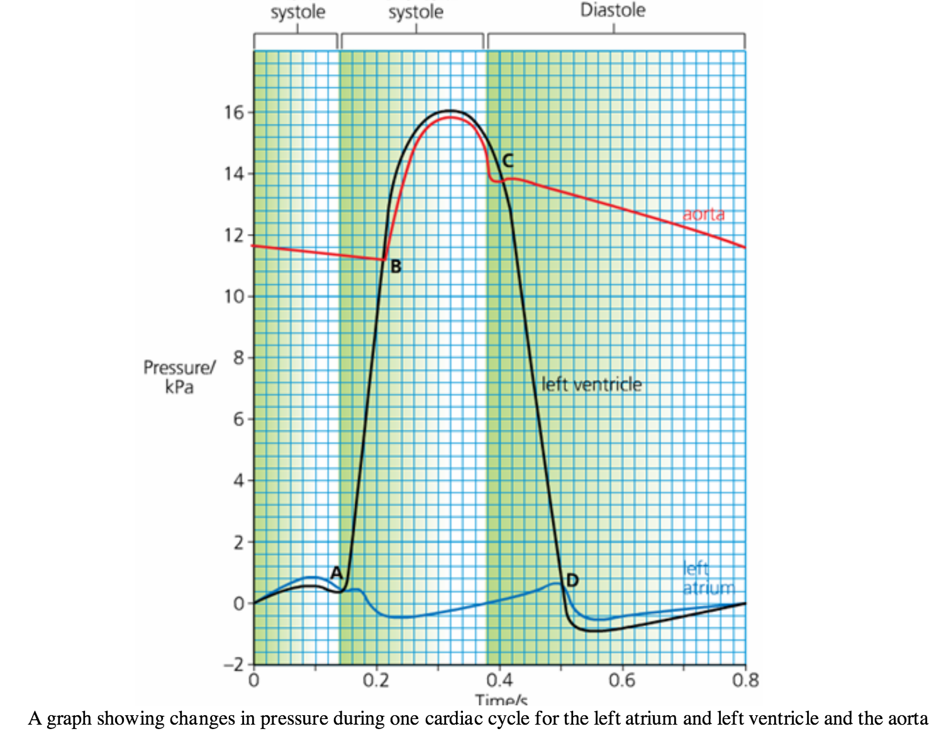
- When is blood being pumped from the atria into the ventricle? Give the start and end time.

- Which letter represents when the ventricular systole begins.

- At what time does the semi lunar valve in the aorta open?

- What letter represents when the semi lunar valve closes?

- At what time is the volume of blood in the ventricle:
- at its maximum
- at its minimum

