1. The diagram below shows a DNA profiling of a family with five children. Segments of the DNA inherited by some members of the family are shown as two dark bands in each column. The DNA fragments are labelled A to F.
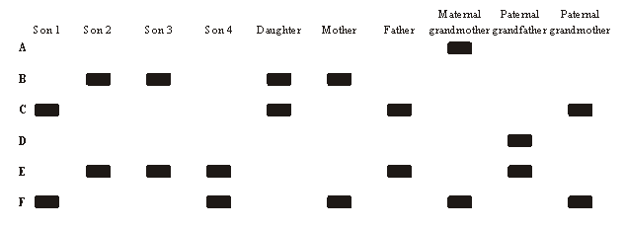
(a) State two properties of the fragmented pieces of DNA which allow them to be separated in gel electrophoresis.
....................................................................................................................................
....................................................................................................................................
(1)
(b) Determine which DNA fragment Son 2 inherited from his mother and which from his father.
From his mother: ........................................................................................................
From his father: ..........................................................................................................
(1)
(c) Identify the child that genetically most resembles one of the grandparents.
....................................................................................................................................
(1)
(d) Apart from determining family relationships, outline one other application for DNA profiling.
....................................................................................................................................
....................................................................................................................................
(1)
(Total 4 marks)

2. The diagram below shows the results of DNA profiling using gel electrophoresis.
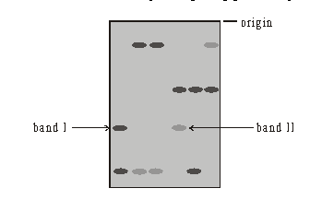
What conclusion can be drawn about the DNA in bands I and II?
A. The DNA in the two bands has the same base sequence.
B. The DNA in the two bands consists of fragments of the same length.
C. The DNA in the two bands has the same ratio of bases.
D. The DNA in the two bands came from the same source.
(Total 1 mark)

3. The following is a DNA gel. The results are from a single probe showing a DNA profile for a man, a woman and their four children.
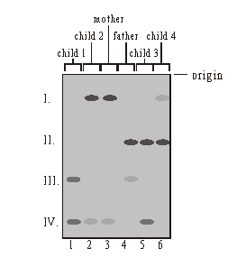
Which child is least likely to be the biological offspring of the father?
A. Child 1
B. Child 2
C. Child 3
D. Child 4
(Total 1 mark)

4. Outline DNA profiling (genetic fingerprinting), including one way in which it has been used.
....................................................................................................................................
....................................................................................................................................
....................................................................................................................................
....................................................................................................................................
....................................................................................................................................
....................................................................................................................................
....................................................................................................................................
....................................................................................................................................
....................................................................................................................................
....................................................................................................................................
....................................................................................................................................
....................................................................................................................................
....................................................................................................................................
....................................................................................................................................

(Total 5 marks)

