ACID RAIN

In many cases the energy comes from burning fossil fuels—coal, oil and natural gas. This is how humans generate electricity. Factories, cars, aeroplanes all release harmful gasses into the atmosphere. This causes pollution and pollution has onsequences for living things
Fig.1 - The diagram below shows the production and consequences of acid rain

How acid rain is produced:

Cars, aeroplanes and factories that burn fossil fuels release harmful gases (sulphur dioxide and nitrous oxide)into the atmosphere. These gases dissolve in the water vapour in clouds. This forms acid rain in the clouds. Clouds can travel great distances, due to winds, before releasing the rain. This means that the effects of acid rain can be seen far from where the harmful gases are produced.

The consequences of acid rain:

When it rains the acid rain falls to the ground. This can have negative consequences on living things in the ecosystem, disrupting feeding relationships. If acid rain falls into water it can kills plants, insects and fish that live in the water. If acid rain lands on the ground it can kill plants which could effect the animals that eat the plants.

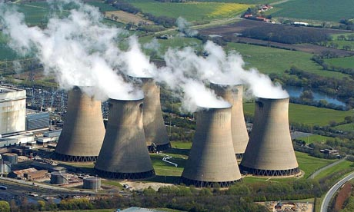
How does acid rain effect ecosystems?
Fig 2 – Drax Power Station

Scientists have been studying ecosystems near Drax, East Yorkshire, UK. Drax is the biggest coal power station in the UK.

The scientists have identified one food web in the Drax ecosystem. They have identified three producers: Pond weed, grass and hawthorn bushes. Robins eat the hawthorn bushes with competition from the rabbits. Rabbits also eat the grass. The pond weed is eatn by fish called Carp. The Carp provide food for Kestrels which are birds of prey and the top predator in the ecosystem. Kestrels also eat Ferrets. The Ferrets eat Rabbits and Robins. The food web can be seen on the right.
Fig 3 - Food web for Drax ecosystem

What could be the consequences of acid rain on this ecosystem?

......................................................................................................................................................................................................................................................
......................................................................................................................................................................................................................................................
......................................................................................................................................................................................................................................................
......................................................................................................................................................................................................................................................
......................................................................................................................................................................................................................................................

